**COFFEE SHOP SALES PROJECT**

**Queries_output_interpretation**

**What are the total sales in month 5?**

SELECT

ROUND(SUM(unit_price * transaction_qty)) as Total_Sales

FROM coffee_shop_sales

WHERE MONTH(transaction_date) = 5;

**OUTPUT**

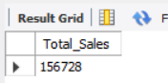

**Interpretation**

It measures overall revenue generated in the month of may.

**How many orders received in the month 5?**

SELECT

COUNT(transaction-id) AS total_orders

FROM coffee_shop_sales

WHERE MONTH(transaction-date) = 5;

**OUTPUT**

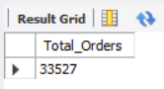

**Interpretation**

Shows 33527 items/products sold in May, illustrating product movement and demand.

**How much quantity sold in month 5?**

SELECT SUM(transaction-qty) AS total_qty_sold

FROM coffee_shop_sales

WHERE MONTH(transaction-date) = 5;

**OUTPUT**

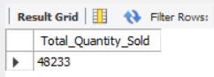

**Interpretation**

Shows 48233 items/products sold in May, illustrating product movement and demand.

**TOTAL SALES KPI - MOM DIFFERENCE AND MOM GROWTH**

WITH monthly_sales AS (

SELECT

MONTH(transaction_date) AS Month,

ROUND(SUM(unit_price * transaction_qty)) AS Total_sales

FROM coffee_shop_sales

WHERE MONTH(transaction_date) IN (4,5)

GROUP BY MONTH(transaction_date)

)

SELECT Month,

Total_sales,

ROUND(

(Total_sales - LAG(Total_sales) OVER (ORDER BY Month))

/ LAG(Total_sales) OVER (ORDER BY Month) * 100, 2

) AS Increase_Decrease_Percentage

FROM monthly_sales

ORDER BY Month;

**OUTPUT**

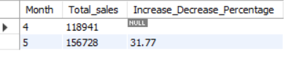  
**Interpretation**

It shows sales has been increased by 31.77% from apirl month to may month.

**TOTAL ORDERS KPI - MOM DIFFERENCE AND MOM GROWTH**with order_analysis as (

select

month(transaction_date) as month,

round(count(transaction_id)) as total_orders

from coffee_shop_sales

where month(transaction_date) in (1,6)

group by month(transaction_date)

)

select

month,

total_orders,

round(

(total_orders - lag(total_orders) over (order by month))

/ Nullif(lag(total_orders) over (order by month),0) *100, 2) as increase_decrease_percentage

from

order_analysis

order by month;

**OUTPUT**

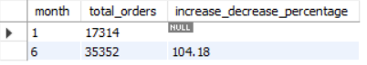

**Interpretation**

It shows total orders has been increased by 104.18% from the month of January to june, it means growth of business.

**TOTAL QUANTITY SOLD KPI - MOM DIFFERENCE AND MOM GROWTH**with quantity_sold as (

select

month(transaction_date) as month,

round(sum(transaction_qty)) as total_quantity_sold

from coffee_shop_sales

where month(transaction_date) in (1,6)

group by month(transaction_date)

)

select

month,

total_quantity_sold,

round(

(total_quantity_sold - lag(total_quantity_sold) over (order by month))

/ Nullif(lag(total_quantity_sold) over (order by month),0) * 100, 2) as increase_decrease_percentage

from

quantity_sold

order by month;

**OUTPUT**

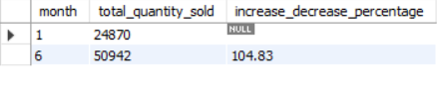

**Interpretation**

Quantity sold has a positive increment from the month of Jan to month June by 104.83%

**Daily sales, orders, quantity for specific date**  
Select

date (transaction_date) as day,

sum(unit_price*transaction_qty) as Total_sales,

count(transaction_id) as Total_orders,

sum(transaction_qty) as Total_quantity_sold

from coffee_shop_sales

where date(transaction_date) = '2023-02-01'

group by day

**OUTPUT**

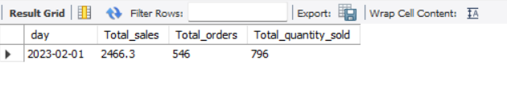**Interpretation**

It is showing us the sales,quantity,orders for the date 2023-02-01.

***If you want to get exact Rounded off values then use***

SELECT

CONCAT(ROUND(SUM(unit_price * transaction_qty) / 1000, 1),'K') AS total_sales,

CONCAT(ROUND(COUNT(transaction_id) / 1000, 1),'K') AS total_orders,

CONCAT(ROUND(SUM(transaction_qty) / 1000, 1),'K') AS total_quantity_sold

FROM

coffee_shop_sales

WHERE

transaction_date = '2023-05-18';

**OUTPUT**



**SALES TREND OVER PERIOD**

**Average of total sales for the month 4,5**

with avg_sales as (

select

month(transaction_date) as month,

concat(round(sum(unit_price*transaction_qty)/1000,1),'k') as sales

from coffee_shop_sales

where month(transaction_date) in (4,5)

group by month(transaction_date)

)

select

month,

sales,

avg(sales) over() as average_sales

from avg_sales;

**OUTPUT**

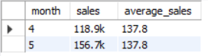

**Interpretation**

Average sales for the month 4,5 is 137.8.

**DAILY SALES FOR MONTH SELECTED**

SELECT

DAY(transaction_date) AS day_of_month,

ROUND(SUM(unit_price * transaction_qty),1) AS total_sales

FROM

coffee_shop_sales

WHERE

MONTH(transaction_date) = 5

GROUP BY

DAY(transaction_date)

ORDER BY

DAY(transaction_date);

**OUTPUT**

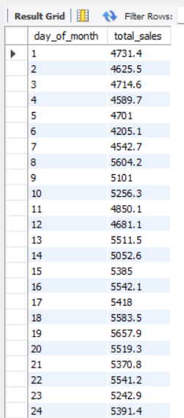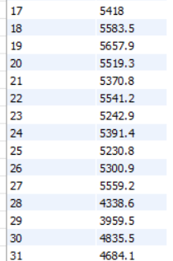

**Interpretation**

Tracks day-by-day business performance, helping spot sales peaks and slow days.

***COMPARING DAILY SALES WITH AVERAGE SALES – IF GREATER THAN “ABOVE AVERAGE” and LESSER THAN “BELOW AVERAGE”***

SELECT

day_of_month,

total_sales,

CASE

WHEN total_sales > avg_sales THEN 'above average'

WHEN total_sales < avg_sales THEN 'below average'

ELSE 'average'

END AS average_status

FROM (

SELECT

DAY(transaction_date) AS day_of_month,

SUM(unit_price * transaction_qty) AS total_sales,

AVG(SUM(unit_price * transaction_qty)) OVER () AS avg_sales

FROM coffee_shop_sales

WHERE MONTH(transaction_date) = 5

GROUP BY DAY(transaction_date)

) AS sales_data

ORDER BY day_of_month;

**OUTPUT**

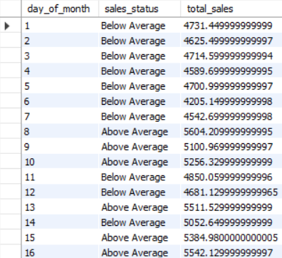 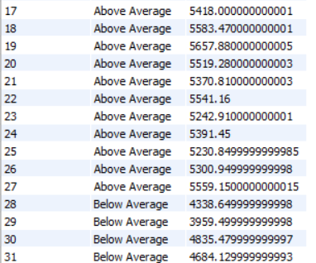

**Interpretation**

Identifies which days performed above or below the monthly average, highlighting outliers.

**SALES BY WEEKDAY / WEEKEND:**

SELECT

CASE

WHEN DAYOFWEEK(transaction_date) IN (1, 7) THEN 'Weekends'

ELSE 'Weekdays'

END AS day_type,

ROUND(SUM(unit_price * transaction_qty),2) AS total_sales

FROM

coffee_shop_sales

WHERE

MONTH(transaction_date) = 5 -- Filter for May

GROUP BY

CASE

WHEN DAYOFWEEK(transaction_date) IN (1, 7) THEN 'Weekends'

ELSE 'Weekdays'

END;

**OUTPUT**

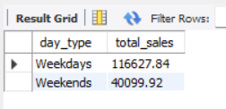

**Interpretation**

Separates sales volume between weekends and weekdays to uncover buying pattern differences.

**SALES BY STORE LOCATION**

select

store_location,

sum(transaction_qty * unit_price) as total_sales

from coffee_shop_sales

where month(transaction_date) = 1

group by store_location

order by sum(transaction_qty * unit_price) desc

**OUTPUT**

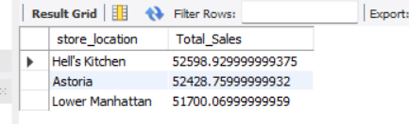

**Interpretation**

Helli’s kitchen store has the highest sales for the month of January  
  
**SALES BY PRODUCT CATEGORY**

SELECT

product_category,

ROUND(SUM(unit_price * transaction_qty),1) as Total_Sales

FROM coffee_shop_sales

WHERE

MONTH(transaction_date) = 5

GROUP BY product_category

ORDER BY SUM(unit_price * transaction_qty) DESC

**OUTPUT**

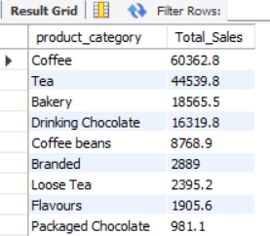

**Interpretation**

Shows COFFEE product is the best sellers, packaged chocolate is worst sellers within the month.

**SALES BY PRODUCTS (TOP 10)**

SELECT

product_type,

ROUND(SUM(unit_price * transaction_qty),1) as Total_Sales

FROM coffee_shop_sales

WHERE

MONTH(transaction_date) = 5

GROUP BY product_type

ORDER BY SUM(unit_price * transaction_qty) DESC

LIMIT 10

**OUTPUT**

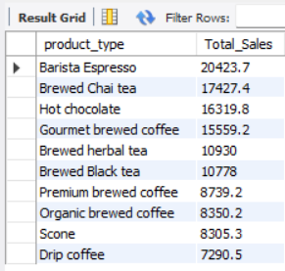

**Interpretation**

Highlights the “Barista Espresso” is the highest-earning individual item, guiding stocking and promotion.

**SALES BY DAY | HOUR**

SELECT

ROUND(SUM(unit_price * transaction_qty)) AS Total_Sales,

SUM(transaction_qty) AS Total_Quantity,

COUNT(*) AS Total_Orders

FROM

coffee_shop_sales

WHERE

DAYOFWEEK(transaction_date) = 3 -- Filter for Tuesday (1 is Sunday, 2 is Monday, ..., 7 is Saturday)

AND HOUR(transaction_time) = 8 -- Filter for hour number 8

AND MONTH(transaction_date) = 5; -- Filter for May (month number 5)

**OUTPUT**

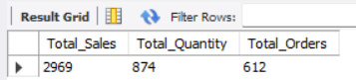

**Interpretation**

It shows the specific hour(8th hour) 5th month sales, quantity, orders.

***TO GET SALES FROM MONDAY TO SUNDAY FOR MONTH OF MAY***

SELECT

CASE

WHEN DAYOFWEEK(transaction_date) = 2 THEN 'Monday'

WHEN DAYOFWEEK(transaction_date) = 3 THEN 'Tuesday'

WHEN DAYOFWEEK(transaction_date) = 4 THEN 'Wednesday'

WHEN DAYOFWEEK(transaction_date) = 5 THEN 'Thursday'

WHEN DAYOFWEEK(transaction_date) = 6 THEN 'Friday'

WHEN DAYOFWEEK(transaction_date) = 7 THEN 'Saturday'

ELSE 'Sunday'

END AS Day_of_Week,

ROUND(SUM(unit_price * transaction_qty)) AS Total_Sales

FROM

coffee_shop_sales

WHERE

MONTH(transaction_date) = 5 -- Filter for May (month number 5)

GROUP BY

CASE

WHEN DAYOFWEEK(transaction_date) = 2 THEN 'Monday'

WHEN DAYOFWEEK(transaction_date) = 3 THEN 'Tuesday'

WHEN DAYOFWEEK(transaction_date) = 4 THEN 'Wednesday'

WHEN DAYOFWEEK(transaction_date) = 5 THEN 'Thursday'

WHEN DAYOFWEEK(transaction_date) = 6 THEN 'Friday'

WHEN DAYOFWEEK(transaction_date) = 7 THEN 'Saturday'

ELSE 'Sunday'

END;

**OUTPUT**

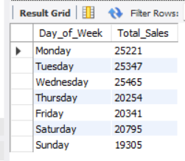

**Interpretation**

It shows the sales by day of the week.

***TO GET SALES FOR ALL HOURS FOR MONTH OF MAY***

SELECT

HOUR(transaction_time) AS Hour_of_Day,

ROUND(SUM(unit_price * transaction_qty)) AS Total_Sales

FROM

coffee_shop_sales

WHERE

MONTH(transaction_date) = 5 -- Filter for May (month number 5)

GROUP BY

HOUR(transaction_time)

ORDER BY

HOUR(transaction_time);

**OUTPUT**

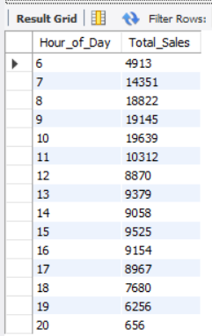

**Interpretation**

Identifies 10th hour is the sales spike during the day, informing staff scheduling and targeted deals.

.